Azure Data Lake Store using the Azure portal

**Step 1:** Sign into your Azure Portal using your credentials and click on **Create a resource** in the upper left-hand corner of the Azure portal and select **Data Lakestore** from the **Storage** category. Fill the necessary details as below to create your Azure Data Lakestore

**Name**: Unique name

**Subscription:** Select your subscription

**Resource group**: Create a new resource group with a name

**Location:** Select the nearest location

**Pricing Package:** Pay-as-You-Go

**Encryption:**

**Encryption Type:** Use keys from your own key valut

Select an existing or create a new key valut and key

Click on **Create** to provision and wait for few mintues for the provision to be succeded.

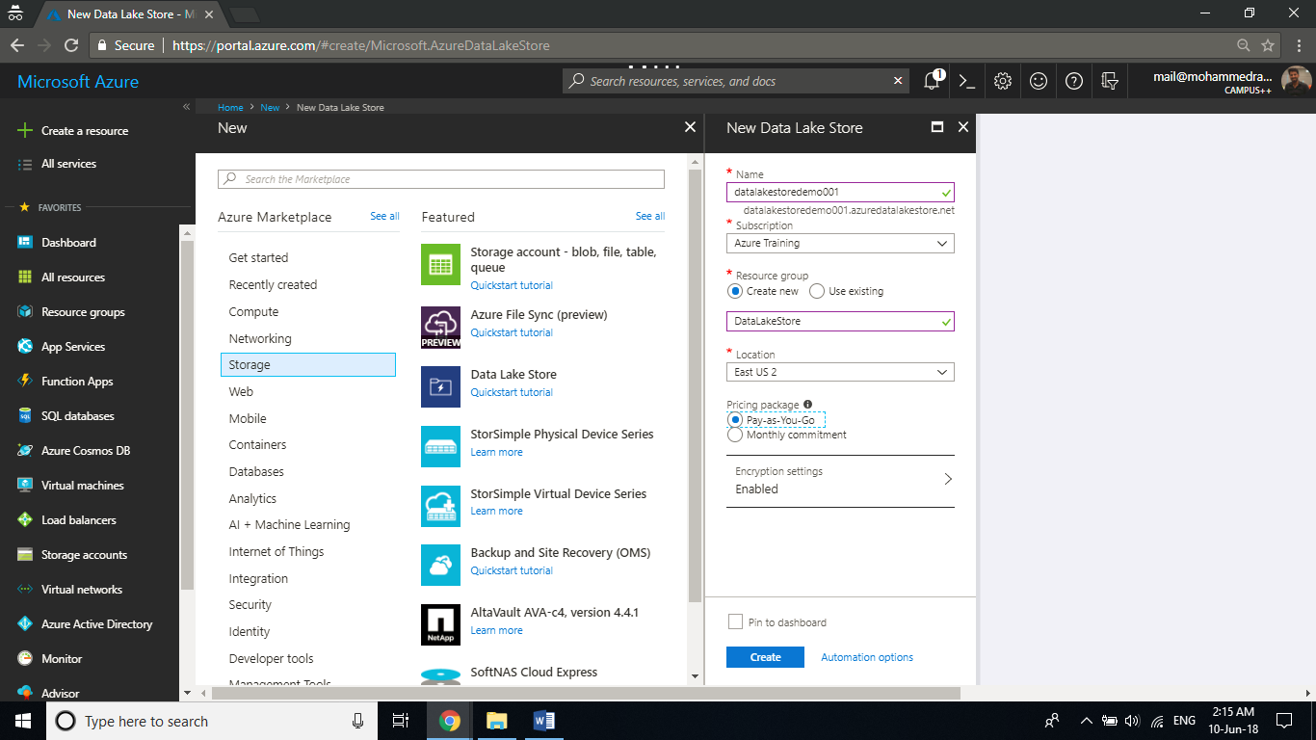

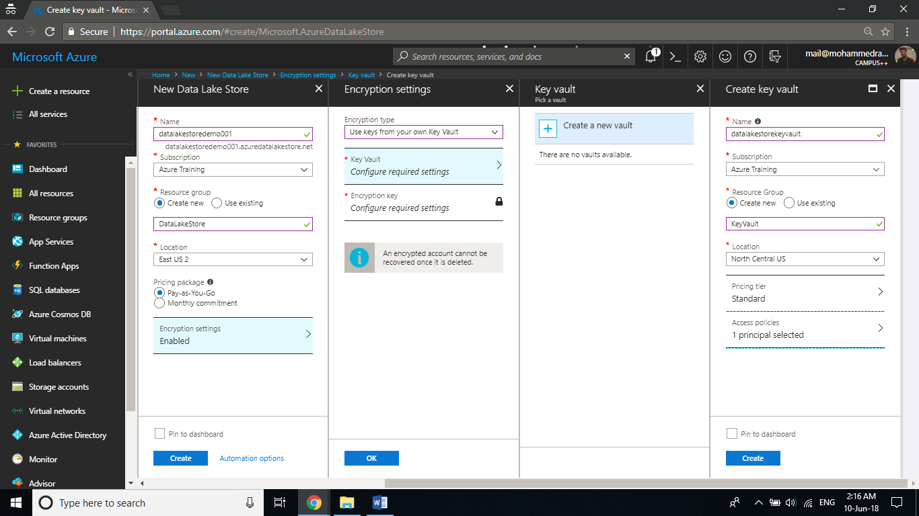

**Step 2:** Once the deployment has succeeded open the resource. Click on **Encryption** tab and **Grant permission**

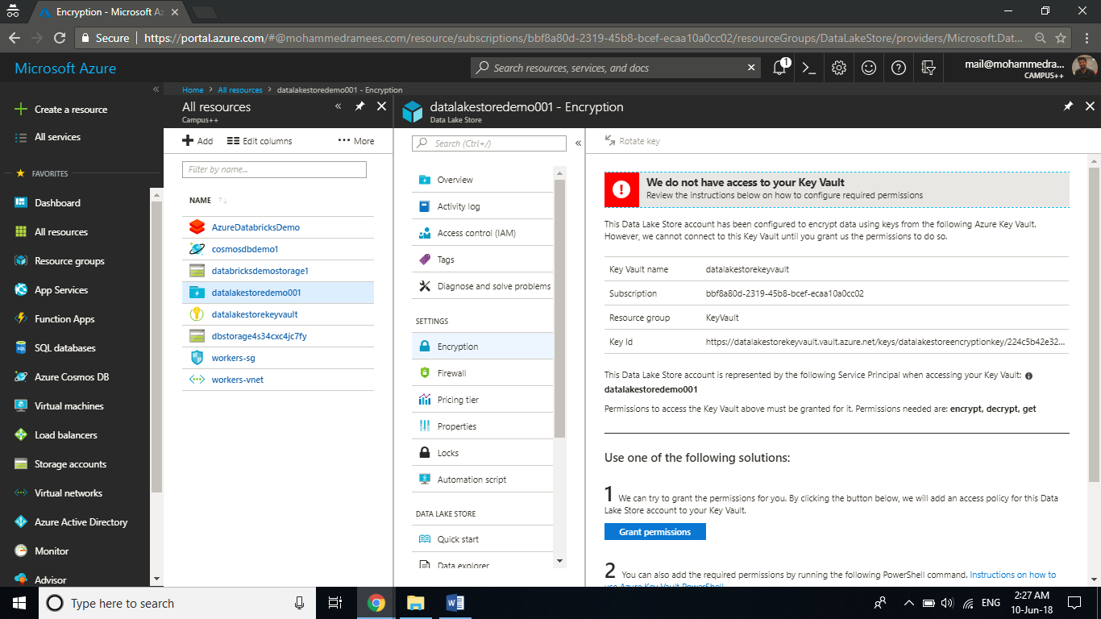

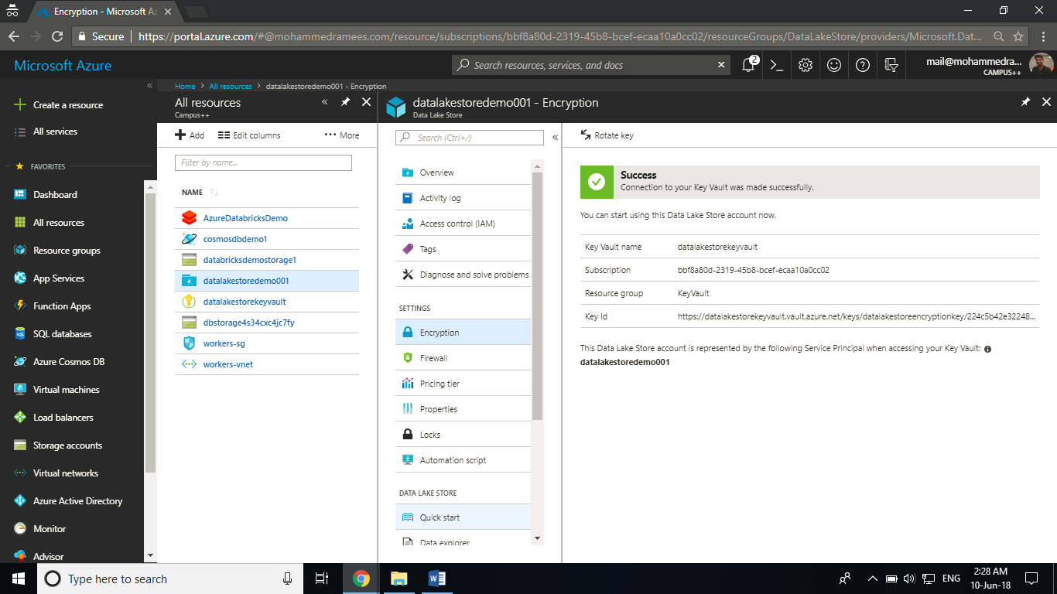

**Step 3:** To create a folder in Data Lake StoreGo back to the **Overview** tab and click on **Data explorer**. Click on New Folder icon and give a name for your folder and you can see your folder created.

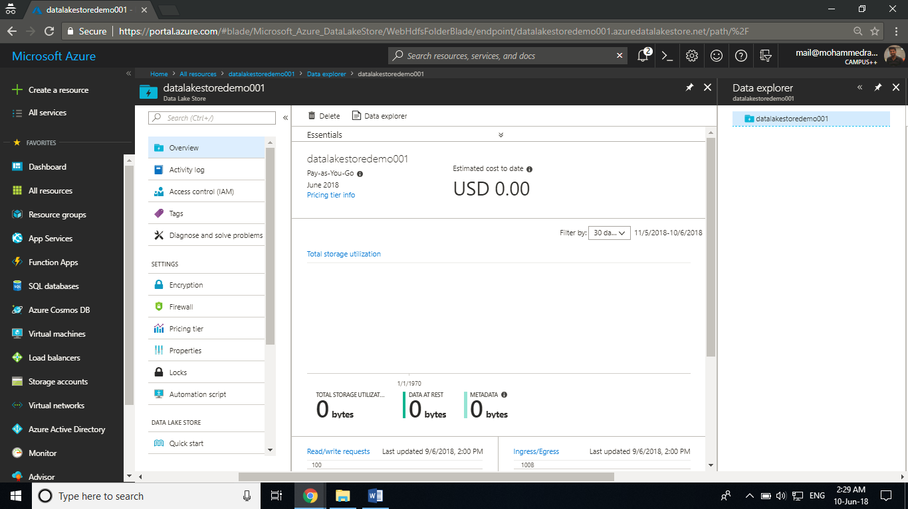

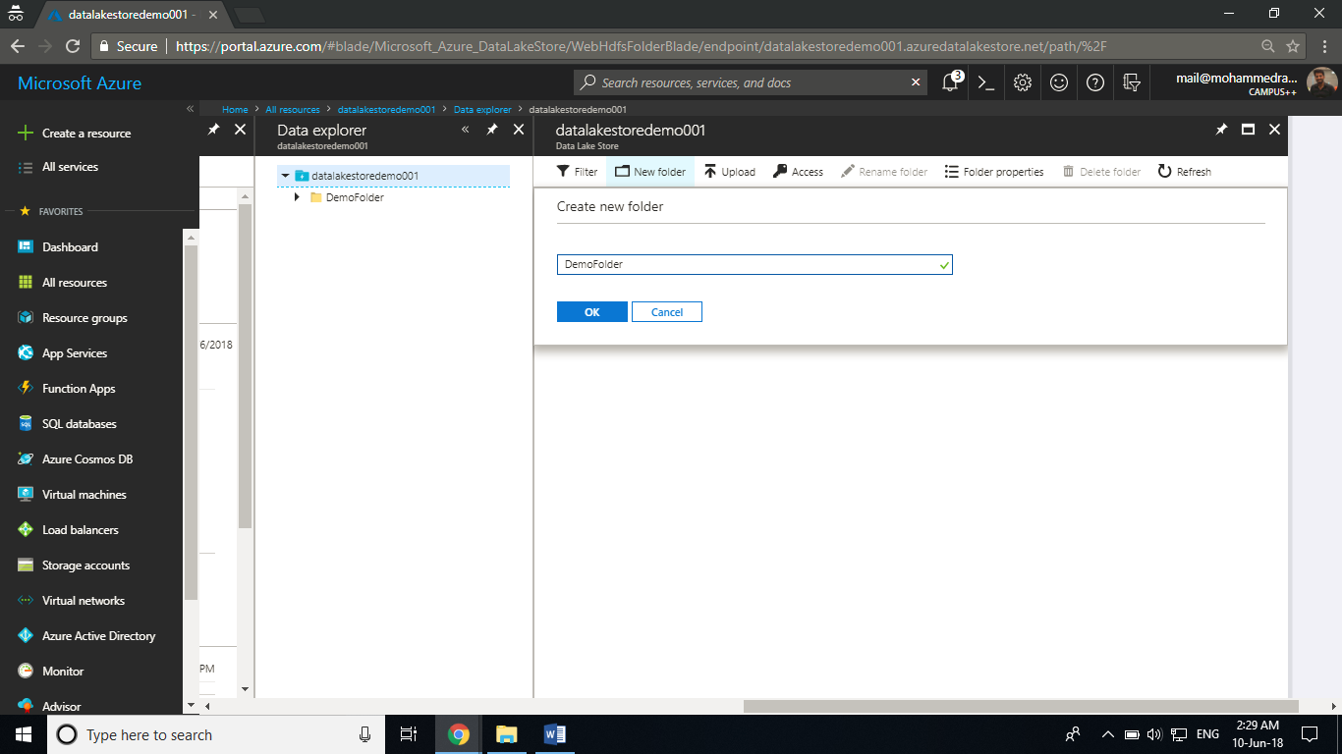

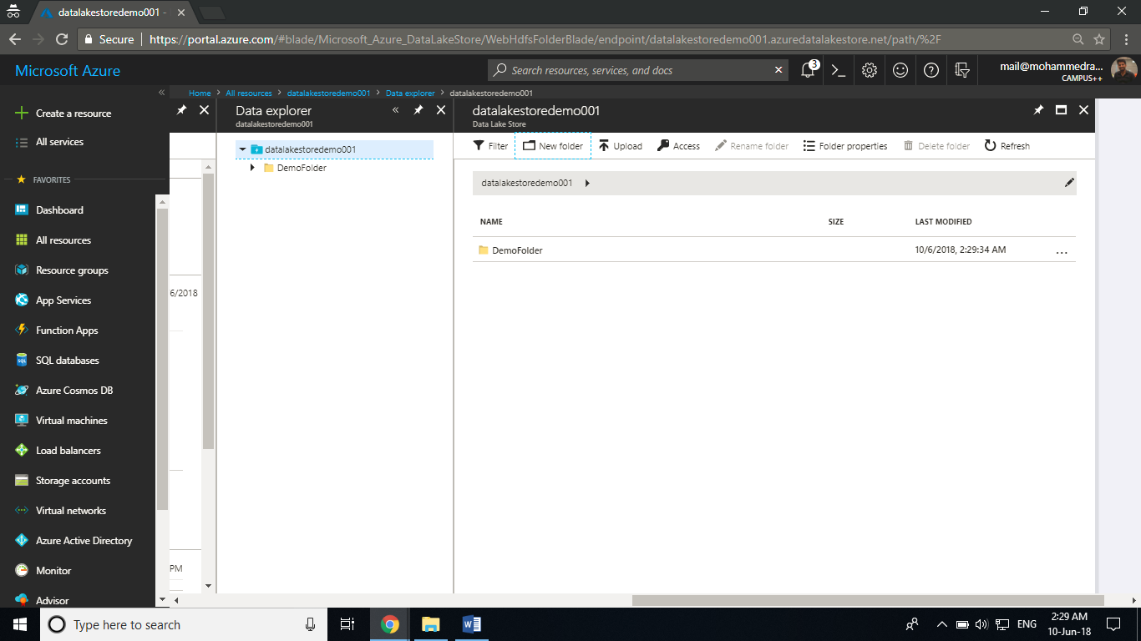

**Step 4:**  To upload any files open your folder and click on upload and browse for your file.

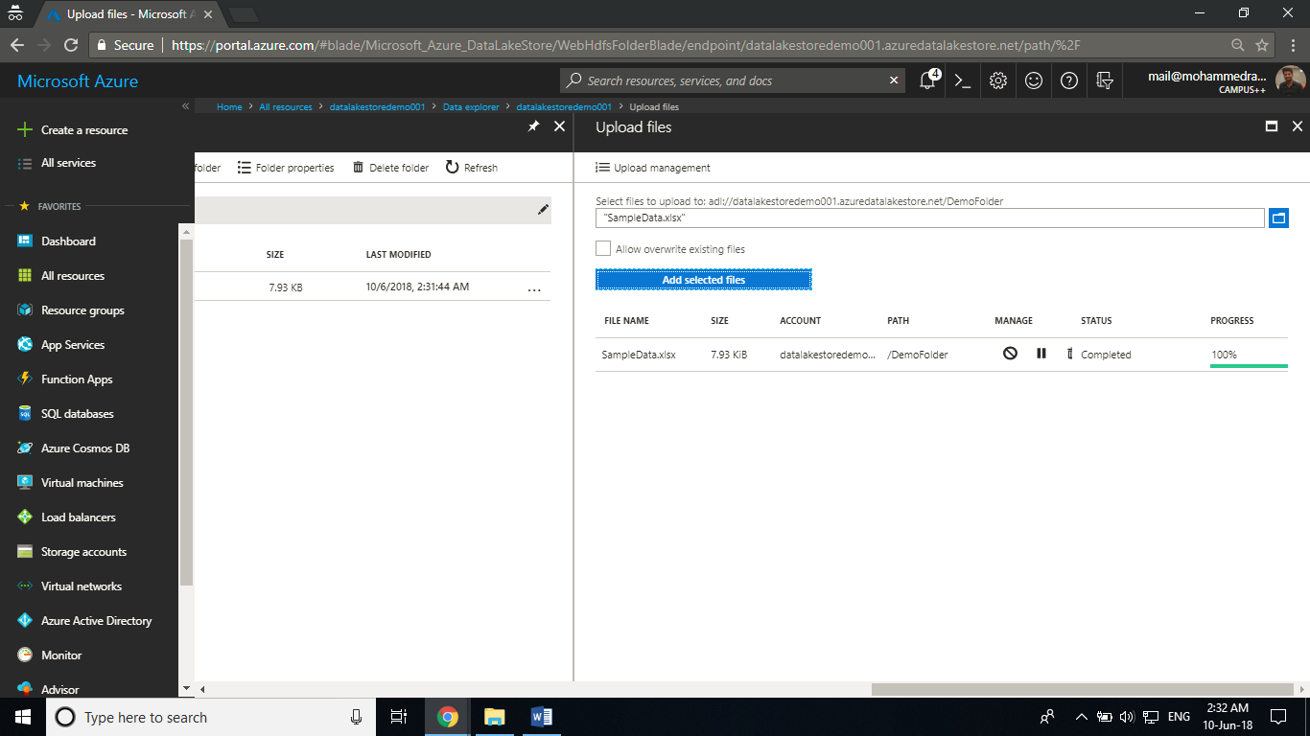

**Step 5:** By right clicking your file you can see various options that you can perform on your file.

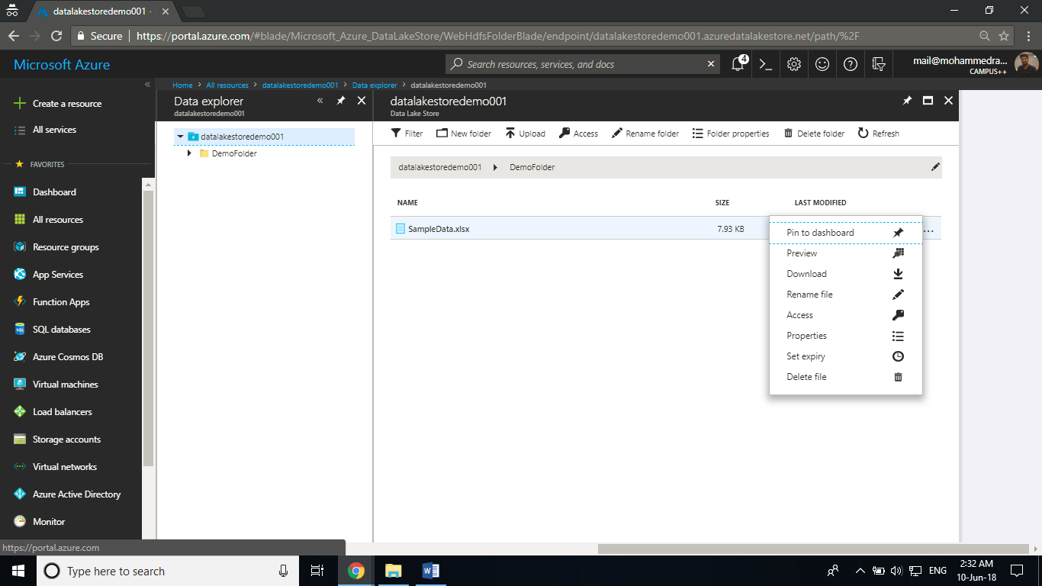

**Step 6:** You can define the access control roles from the **Access control** tab from the settings blade and adding users.

